**Hello World RESTful Web Service**

Code:

SpringLearnApplication.java

package com.cognizant.spring_learn;  
  
import org.springframework.boot.SpringApplication;  
import org.springframework.boot.autoconfigure.SpringBootApplication;  
  
@SpringBootApplication  
public class SpringLearnApplication {  
  
 public static void main(String[] args) {  
 SpringApplication.run(SpringLearnApplication.class, args);  
 }  
  
}

HelloController.java

**package** com.cognizant.spring_learn.controller;

**import** org.slf4j.Logger;

**import** org.slf4j.LoggerFactory;

**import** org.springframework.web.bind.annotation.GetMapping;

**import** org.springframework.web.bind.annotation.RestController;

@RestController

**public** **class** HelloController {

**private** **static** **final** Logger ***LOGGER*** = LoggerFactory.*getLogger*(HelloController.**class**);

@GetMapping("/hello")

**public** String sayHello() {

***LOGGER***.info("START: sayHello()");

String message = "Hello World!!";

***LOGGER***.info("END: sayHello()");

**return** message;

}

}

Output:

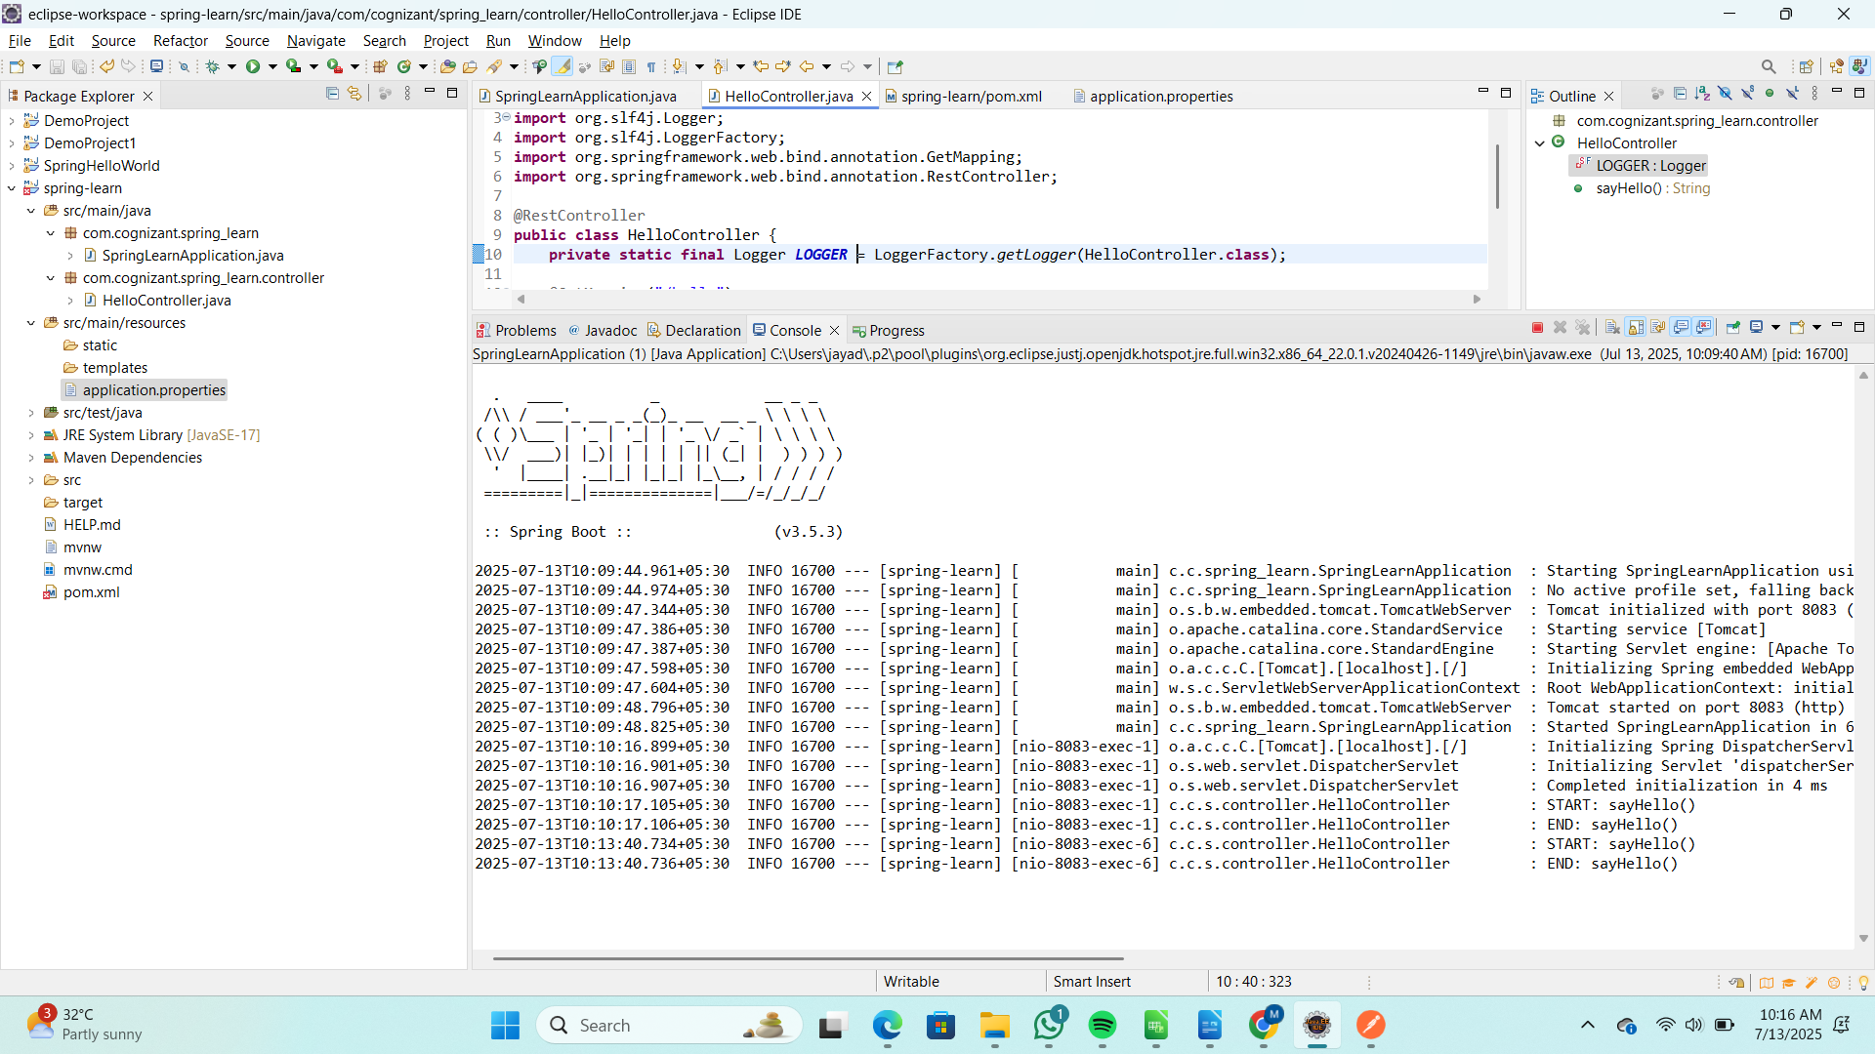  
  
  
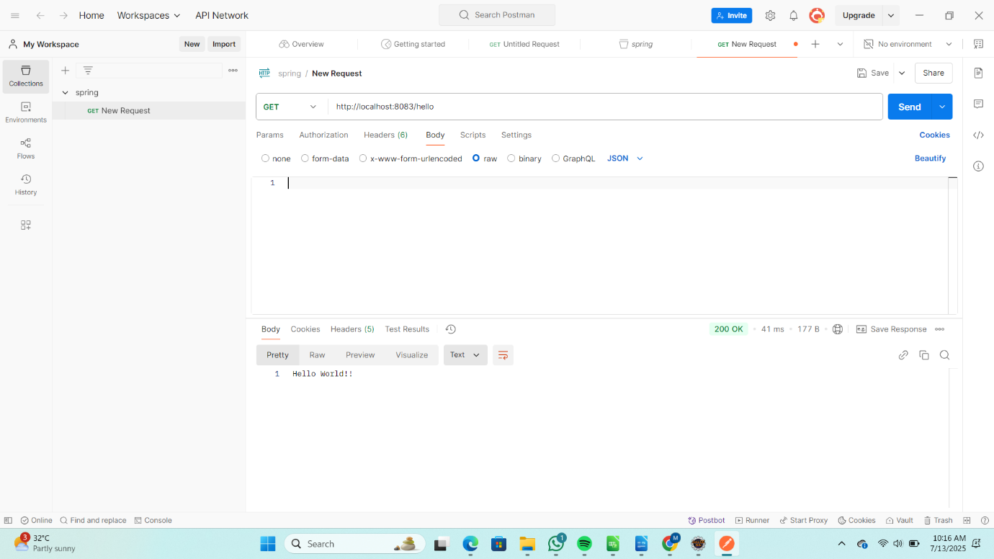

**Country Web Service**

Code:

SpringLearnApplication.java

package com.cognizant.spring_learn;  
  
import org.springframework.boot.SpringApplication;  
import org.springframework.boot.autoconfigure.SpringBootApplication;  
  
@SpringBootApplication  
public class SpringLearnApplication {  
  
 public static void main(String[] args) {  
 SpringApplication.run(SpringLearnApplication.class, args);  
 }  
  
}

CountryController.java

**package** com.cognizant.spring_learn.controller;

**import** com.cognizant.spring_learn.model.Country;

**import** org.slf4j.Logger;

**import** org.slf4j.LoggerFactory;

**import** org.springframework.context.support.ClassPathXmlApplicationContext;

**import** org.springframework.web.bind.annotation.RequestMapping;

**import** org.springframework.web.bind.annotation.RestController;

@RestController

**public** **class** CountryController {

**private** **static** **final** Logger ***LOGGER*** = LoggerFactory.*getLogger*(CountryController.**class**);

@RequestMapping("/country")

**public** Country getCountryIndia() {

***LOGGER***.info("START: getCountryIndia()");

ClassPathXmlApplicationContext context = **new** ClassPathXmlApplicationContext("country.xml");

Country in = (Country) context.getBean("in");

***LOGGER***.info("END: getCountryIndia()");

**return** in;

}

}

Country.java

**package** com.cognizant.spring_learn.model;

**public** **class** Country {

**private** String code;

**private** String name;

**public** String getCode() {

**return** code;

}

**public** **void** setCode(String code) {

**this**.code = code;

}

**public** String getName() {

**return** name;

}

**public** **void** setName(String name) {

**this**.name = name;

}

@Override

**public** String toString() {

**return** "Country [code=" + code + ", name=" + name + "]";

}

}

country.xml

<?xml version="1.0" encoding="UTF-8"?>

<beans xmlns="http://www.springframework.org/schema/beans"

xmlns:xsi="http://www.w3.org/2001/XMLSchema-instance"

xsi:schemaLocation="

http://www.springframework.org/schema/beans

https://www.springframework.org/schema/beans/spring-beans.xsd">

<bean id="in" class="com.cognizant.spring_learn.model.Country">

<property name="code" value="IN"/>

<property name="name" value="India"/>

</bean>

</beans>

Output:

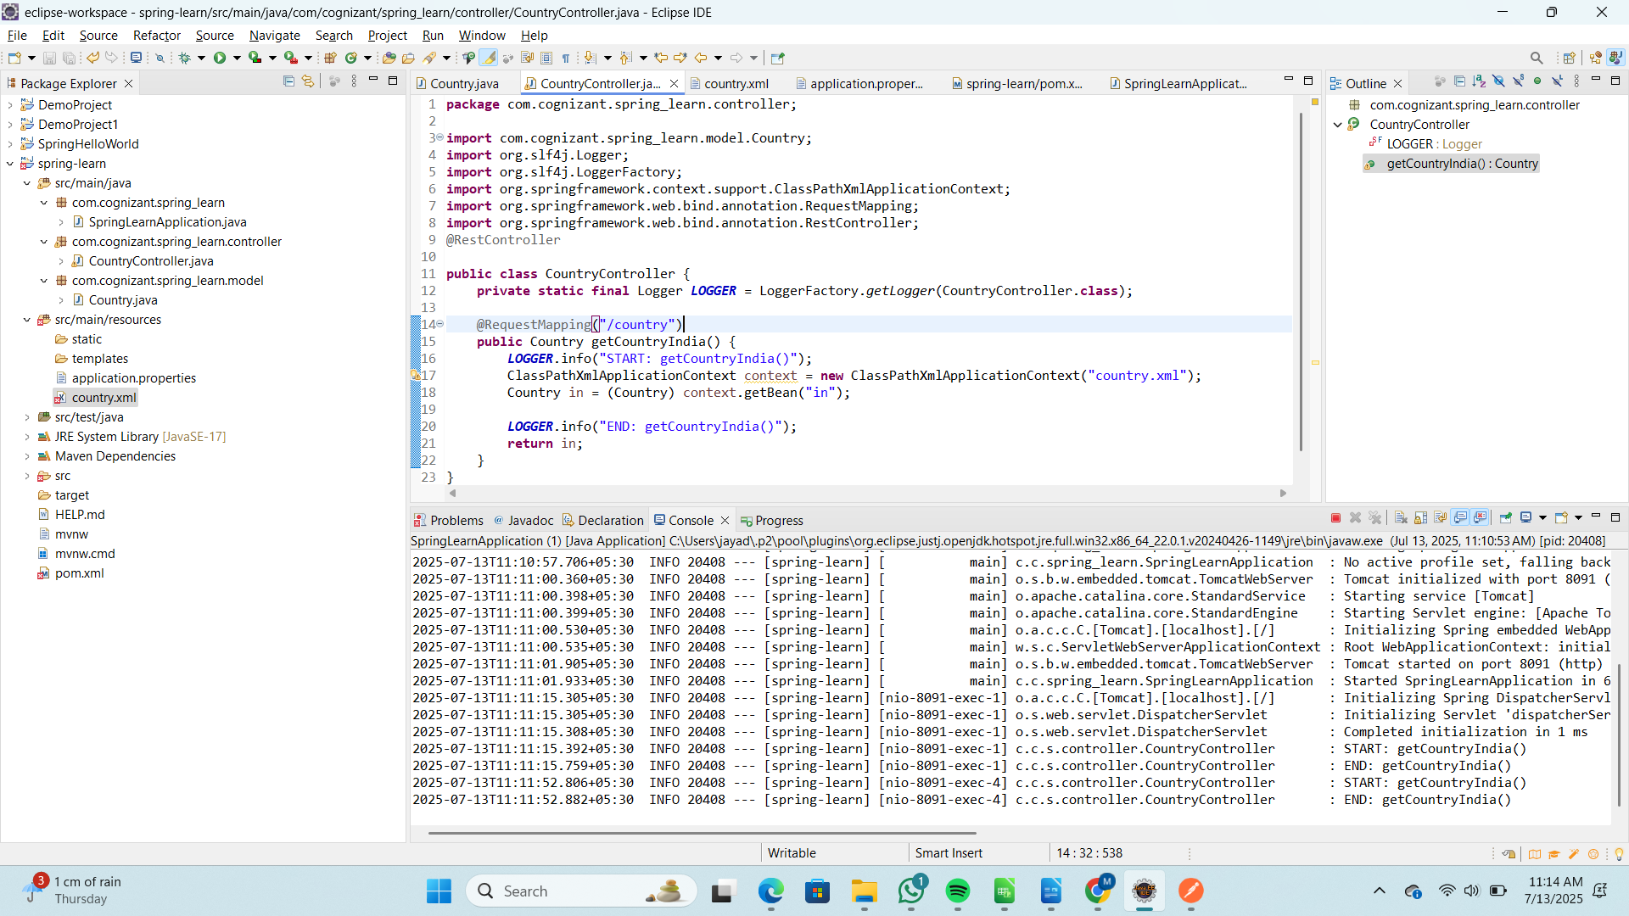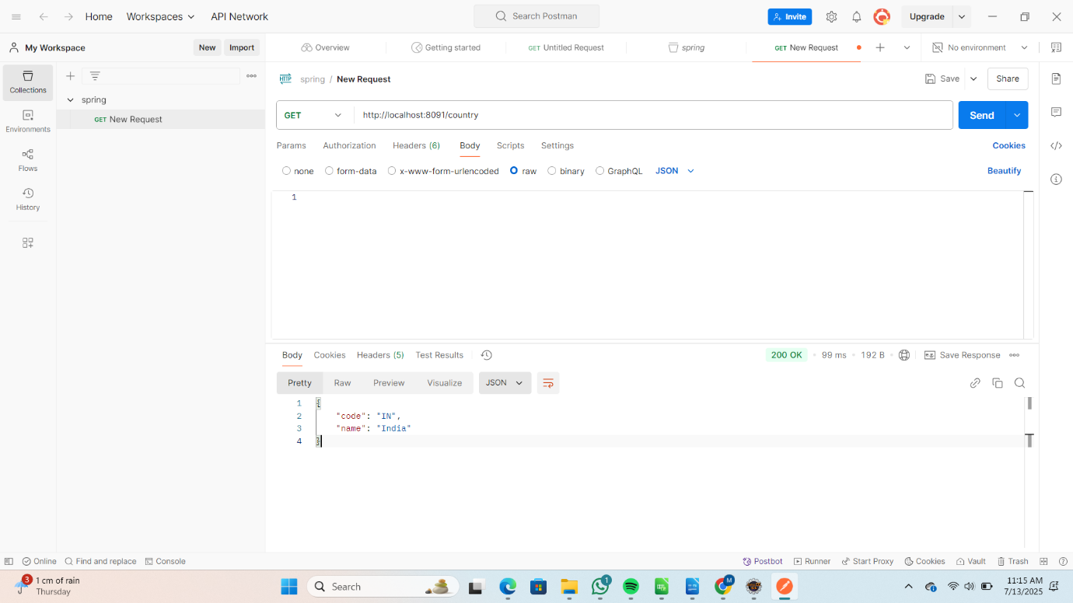

**Get country based on country code**

Code:

SpringLearnApplication.java

package com.cognizant.spring_learn;  
  
import org.springframework.boot.SpringApplication;  
import org.springframework.boot.autoconfigure.SpringBootApplication;  
  
@SpringBootApplication  
public class SpringLearnApplication {  
  
 public static void main(String[] args) {  
 SpringApplication.run(SpringLearnApplication.class, args);  
 }  
  
}  
  
CountryController.java

**package** com.cognizant.spring_learn.controller;

**import** org.springframework.beans.factory.annotation.Autowired;

**import** org.springframework.web.bind.annotation.*;

**import** com.cognizant.spring_learn.model.Country;

**import** com.cognizant.spring_learn.service.CountryService;

@RestController

**public** **class** CountryController {

@Autowired

**private** CountryService countryService;

@GetMapping("/countries/{code}")

**public** Country getCountry(@PathVariable String code) {

**return** countryService.getCountry(code);

}

}

Country.java

**package** com.cognizant.spring_learn.model;

**public** **class** Country {

**private** String code;

**private** String name;

**public** String getCode() {

**return** code;

}

**public** **void** setCode(String code) {

**this**.code = code;

}

**public** String getName() {

**return** name;

}

**public** **void** setName(String name) {

**this**.name = name;

}

@Override

**public** String toString() {

**return** "Country [code=" + code + ", name=" + name + "]";

}

}

CountryService.java

**package** com.cognizant.spring_learn.service;

**import** java.util.List;

**import** java.util.Optional;

**import** org.springframework.context.support.ClassPathXmlApplicationContext;

**import** org.springframework.stereotype.Service;

**import** com.cognizant.spring_learn.model.Country;

@Service

**public** **class** CountryService {

**public** Country getCountry(String code) {

ClassPathXmlApplicationContext context = **new** ClassPathXmlApplicationContext("country.xml");

List<Country> countries = (List<Country>) context.getBean("countries");

context.close();

Optional<Country> countryOptional = countries.stream()

.filter(c -> c.getCode().equalsIgnoreCase(code))

.findFirst();

**return** countryOptional.orElse(**null**);

}

}

country.xml

<?xml version="1.0" encoding="UTF-8"?>

<beans xmlns="http://www.springframework.org/schema/beans"

xmlns:xsi="http://www.w3.org/2001/XMLSchema-instance"

xsi:schemaLocation="http://www.springframework.org/schema/beans

https://www.springframework.org/schema/beans/spring-beans.xsd">

<bean id="in" class="com.cognizant.spring_learn.model.Country">

<property name="code" value="IN"/>

<property name="name" value="India"/>

</bean>

<bean id="us" class="com.cognizant.spring_learn.model.Country">

<property name="code" value="US"/>

<property name="name" value="United States"/>

</bean>

<bean id="countries" class="java.util.ArrayList">

<constructor-arg>

<list>

<ref bean="in"/>

<ref bean="us"/>

</list>

</constructor-arg>

</bean>

</beans>

Output:

